Assignment Activity Unit 1
Godfrey Ouma
University of the People
CS 1105-01: Digital Electronics & Computer Architecture
Afrah Nazir
June 27, 2024

Assignment Activity Unit 1
Scenario:
John is an electronics enthusiast who loves designing and building digital circuits using Boolean algebra and logic gates. He has been tasked with creating a simple circuit that can turn on a light bulb using a switch. John wants to utilize his knowledge of Boolean algebra and logic gates to design an efficient and reliable circuit for this purpose.
Assignment:
Using Boolean algebra and logic gates, design a digital circuit that can control a light bulb with a switch. The circuit should meet the following conditions:
- The light bulb should turn on when the switch is closed (ON position) and turn off when the switch is open (OFF position).
- Use the fewest number of logic gates possible to keep the circuit simple and efficient.
- Clearly depict the logic gates you choose to use and explain the reasoning behind your choices.
Requirements of the circuit
The circuit requires constructing an XNOR gate since it produces a HIGH (Logic 1) output when both inputs are the same, and LOW (Logic 0) when the inputs differ (Tutorials Point, 2024). In addition, a NAND gate will be used to construct the XNOR gate because it is a universal gate, hence can be used to implement any type of logic gate of choice. The truth table of the XNOR gate will be as follows: $AʘB=AB+\overline{A}\overline{B}$
A | B | AB | $$\overline{A}$$ | $$\overline{B}$$ | $$\overline{A}\overline{B}$$ | $$AB+\overline{A}\overline{B}$$
0 | 0 | 0 | 1 | 1 | 1 | 1
0 | 1 | 0 | 1 | 0 | 0 | 0
1 | 0 | 0 | 0 | 1 | 0 | 0
1 | 1 | 1 | 0 | 0 | 0 | 1

For the XNOR gate, the Boolean equation is $AʘB=AB+\overline{A}\overline{B}$.
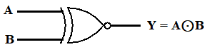
Fig. 1: XNOR gate
For the NAND gate, the Boolean equation is $\overline{AB}$.
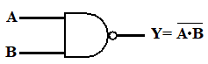
Fig. 2: NAND gate
Implementation of XNOR Gate from NAND Gate
Since the NAND gate is a universal logic (Ndjountche, 2016), it can be used to implement any other type of logic gate. Therefore, the implementation of the XNOR gate using NAND gates will be as shown in fig. 3.
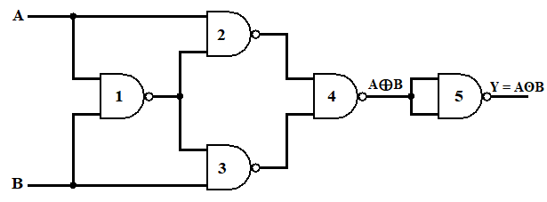
Fig. 3: Implementation of XNOR gate using NAND gate
It is evident from fig. 3 that we need 5 gates to construct the XNOR gate using the NAND gate. Therefore, we need to get the outputs from each gate and then combine them.
Output from gate 1: $Y_{1}=\overline{AB}$.
Output from gate 2: $Y_{2}=A\left(\overline{A}+\overline{B}\right)$.
Output from gate 3: $Y_{3}=B(\overline{A}+\overline{B})$.
Output from gate 4: $Y_{4}=Y_{2}+Y_{3}=A\left(\overline{A}+\overline{B}\right)+B(\overline{A}+\overline{B})$.
By law of distribution,
$$A\left(\overline{A}+\overline{B}\right)+B\left(\overline{A}+\overline{B}\right)=A\overline{A}+A\overline{B}+B\overline{A}+B\overline{B}$$
By inverse law, $A\overline{A}=0$ and $B\overline{B}=0$
$$A\overline{A}+A\overline{B}+B\overline{A}+B\overline{B}=0+A\overline{B}+B\overline{A}+0=A\overline{B}+B\overline{A}$$
Therefore, $Y_{4}=A\overline{B}+B\overline{A}=A⊕B$.
The output $Y_{4}$ is the input to the fifth NAND gate that functions as an inverter, which produces an output equivalent to the XNOR gate as follows:
$$Y_{5}=\overline{A\overline{B}+B\overline{A}}=AB+\overline{A}\overline{B}=AʘB$$

References
Ndjountche, T. (2016). Digital electronics 1: Combinational logic circuits. John Wiley & Sons, Incorporated.
Tutorials Point. (2024). Implementation of XNOR gate from NAND gate. Quality Tutorials, Video Courses, and eBooks. https://www.tutorialspoint.com/implementation-of-xnor-gate-from-nand-gate

